Foundations of Programming

(Main in js)

|  |  |  |  |
| --- | --- | --- | --- |
| Compiled | | Interpreted | |
| Ready to run | Not cross platform | Cross platform | Interpreter required |
| Often faster | Inflexible | Simpler test | Often slower |
| SRC code private | Extra step | Easier to debug | SRC is slower |

**Basics**

**JIT** – Just in Time; byte code

**Compiled**

* C,C++,Objective-C

**Interpreted**

* PHP, JS (Most with script name)

**Hybrid**

* Java, C#, VB.NET, Python

**Scripting Languages –** Are more limited programming languages that are embedded inside another program.

**Terminology**

( Parentheses )

[ Brackets ]

{ Braces }

**Switch Statement**

Break prevents code fall through. Meaning it will not execute other case’s in the switch statement.

**Functions**

Function that calls itself is known as **recursion**

Function addTwoNumbers(a,b) {

// a,b parameters

var result = a + b;

alert(result);

}

**addTwoNumbers(5,10);**

**// 5,10 are arguments**

In JavaScript only worry about scope with functions.

**Fencepost Error**

Off by One

You need to build a straight fence and it must be 50 meters wide and you need fence posts every 10 meters? How many fence posts do you need? **6**

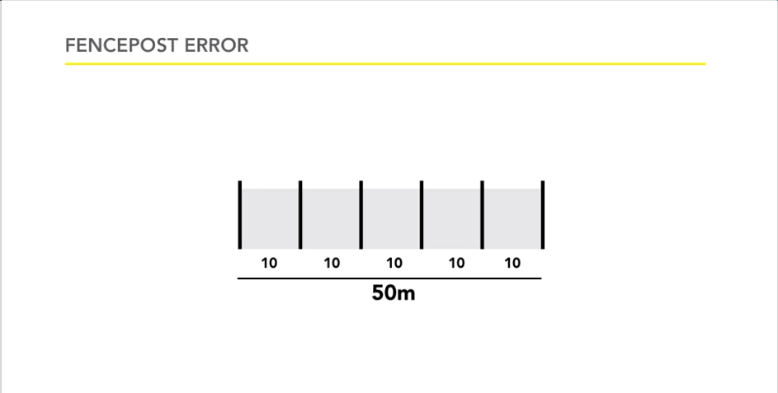

**Loops**

**While**

//Set up index

var i = 0;

//check condition

while (i < 10) {

//Do stuff

//increment index

i++;

}

**for loop**

//setup index //check condition //increment index

for( var i=1; i<10; i++){

//do stuff

}

Regex

* Pattern matching in strings
* Not pleasant, but quite useful
* Two parts
  + Create Expression
  + Apply and ask if matches

Array

* Great way to keep data together that belongs together, without having to name every single individual piece as an individual variable.
* Only limited by amount of memory available.
* Zero-based index
* Often referred to as a collection –multiple values grouped together in some way.
* **Arrays are objects**

Style

* Your code should be easily readable.
* Your code should be consistent.
* Your code should know accepted best practices.
  + There are many style guidelines google, yahoo, abnb
* Use camelCase for variables, functions, & methods.
* Open curly braces on the same line.
* Define your functions before you call them.
* Always use semicolons to end a statement.
* Always use var when declaring a variable.

Pseudo Code

Can be a code practice before you start coding. Just to understand the logic.

IF balance < 0

Display “balance is negative!” message

ELSE

Display “balance OK” message

END IF

Input & Output

Programming is all about I/O. Programs use to only be batch programs. Give file of data for input, let program process data, and spit out result to another file or to printer. You did not interact with program.

Example

* CLI
* Virus Scan

Persistence – Saves state of program

DOM

Document – Web page

Objects – Elements, components, pieces of documents

Model – What do we call individual pieces? Relationships between them

|  |  |  |
| --- | --- | --- |
| **Document** | **Object** | **Model** |
| Web page | Pieces | Agreed upon terms |

The DOM is the way to reach into the page from our script and vice versa. Learning DOM most important JS skill.

Event Driven Programming

Event handler/listener: function that’s waiting for event to happen

**Event Names**

* onload
* onclick
* onmouseover
* onblur
* onfocus

**2 pieces of info**

* What is event?
* What to do?

element.event = window.onload

myelement.onclick = function () {

//anonymous function runs with onclick

};

Example

var headline = document.getElementById(“mainHeading”);

headline.onclick = function(){

headline.innerHTML = “You clicked me!”;

};

Debugging

Do not expect code to work!!

**Syntax errors**

* Alert(“Hello, world”);
* alert(“Hello, world”):
* alert(“Hello, world’);
* alert(“Hello, world”);

**Steps to problem solve**

* Alert message – To see if code is even getting to a particular point.
  + These are known as trace meessages- logging to the console.

Object Oriented

Each object represents a different part of the app. A Class is a blueprint, the definition, and the description. The Object is created from the Class. One class can create multiple objects.

Classes are self-contained units with properties and methods.

What does a class define?

|  |  |
| --- | --- |
| Attributes/properties | Behavior/methods |
| Name | Walk |
| Height | Run |
| Weight | Jump |
| Gender | Speak |
| Age | Sleep |

var today = new Date();

A new variable called today is created and it will be a Date object based on the Date class.

Misc

**Multithreading**

* Completing for resources
* Restrictions on updating UI
* Language support
* JS does not have multithreading yet

